Roadmap M.F.L.S. site
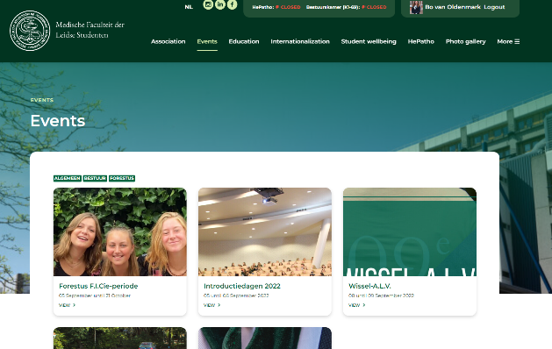

Subscribe to activities/download activities in your own calendar
- Go to “Events” > “Overview”
- Click “View”
- Log in to register.
- Click “Opslaan in kalender (ICS)” to download the activity into your own calendar

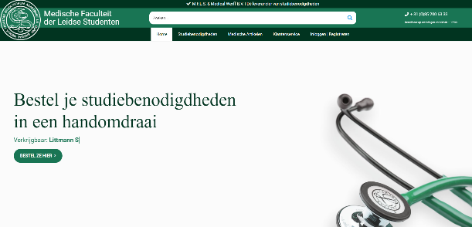
Purchase educational materials
- Go to “Educational Materials”.
  - “Study books” > here you can find a button to the cheapest textbooks via INDEX books and a list of required literature.
  - “Instruments and Clothing” > here you will find a button to the best and cheapest instruments and lab coats via Medical Werff.
  - “Course guides” > here you will find a link to the online blockbooks.
  - “Dissection manuals”> here you will find a link to the online dissection manuals.

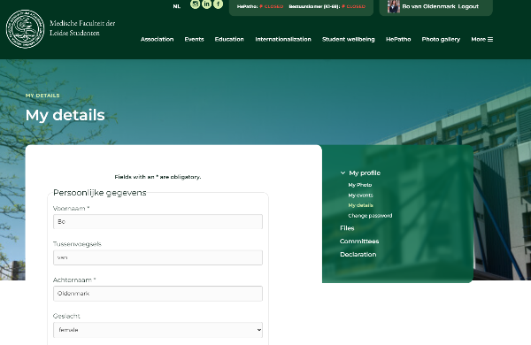
Customize personal information
- Go to “My M.F.L.S.”
- Enter your username and password.
- Go to “My profile”
  - “My details” > Enter here your personal information
  - “My events” > Register for the different activities
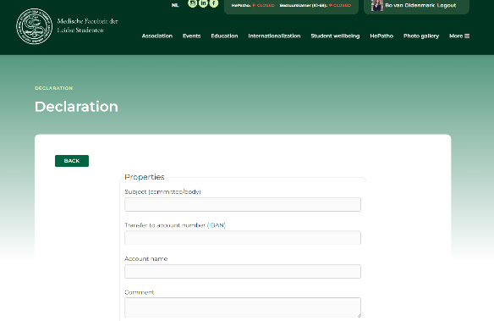
- Upload a passport photo via “My Photo”.

Fill in an declaration form
- Go to “My M.F.L.S.”
- Enter your username and password.
- Go to “Declaration” > “Add”
- Enter the following information:
  - Subject: What committee are you in?
  - Account number (IBAN)
  - Account name
  - Comment
- Enter the declaration form:
  - Date
  - Issue: What did you spend money on?
  - Amount: How much money have you spent?
  - Receipt: upload a scan, photo or document of your receipt or invoice
    - NOTE: This document must contain the VAT information.

